API Testing – RestAssured

## Post Request

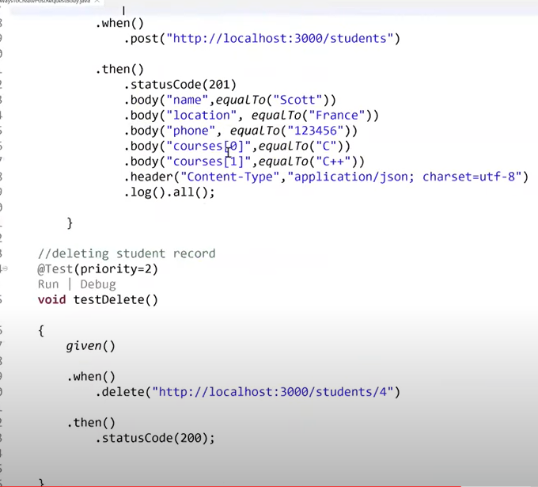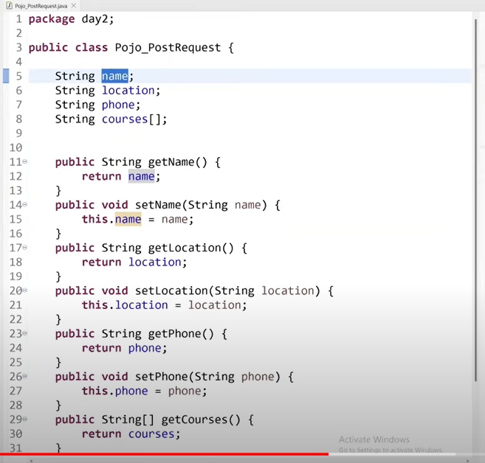

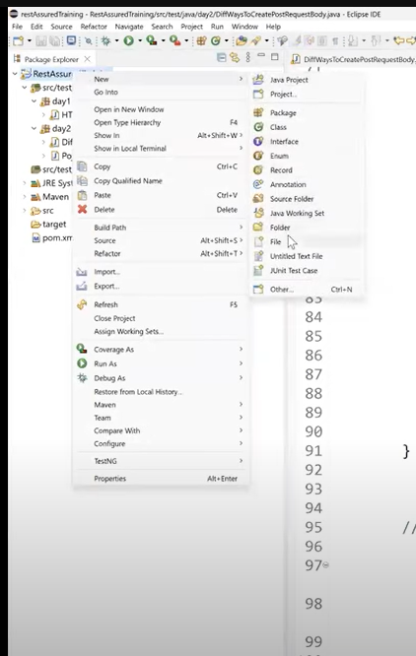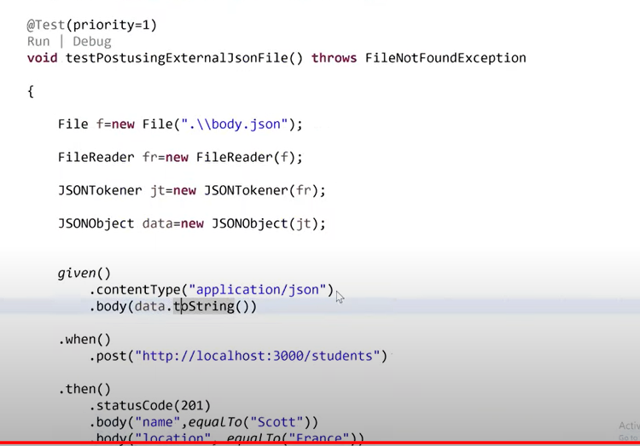

## Path & Query Parameters

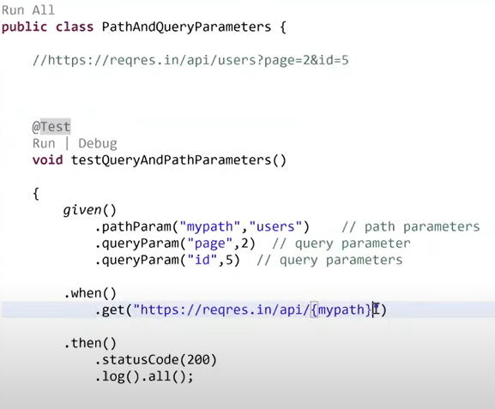

## Cookies

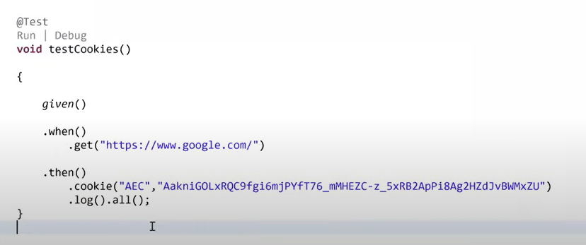

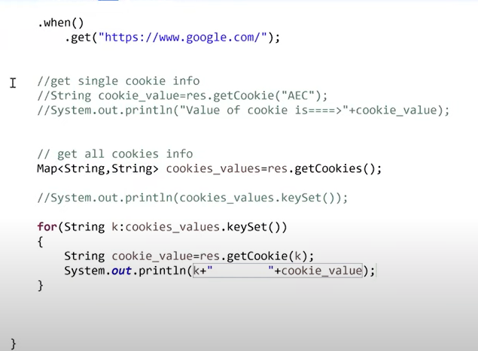

## Headers

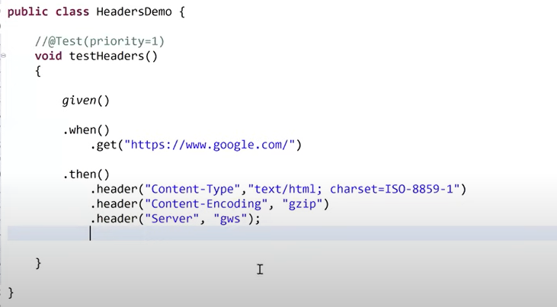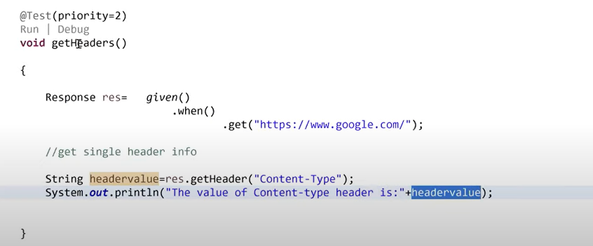

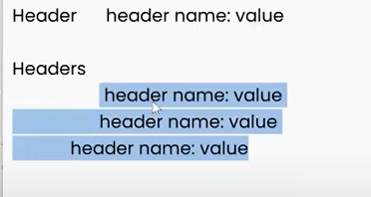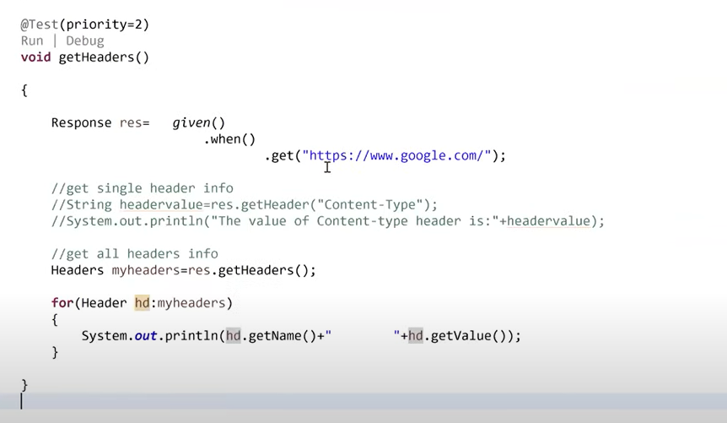

## Logging

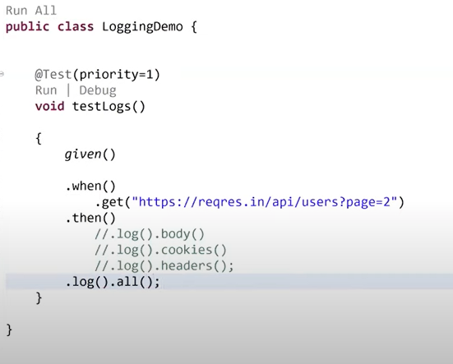

## Parsing / Validation Response Body-JSON Response

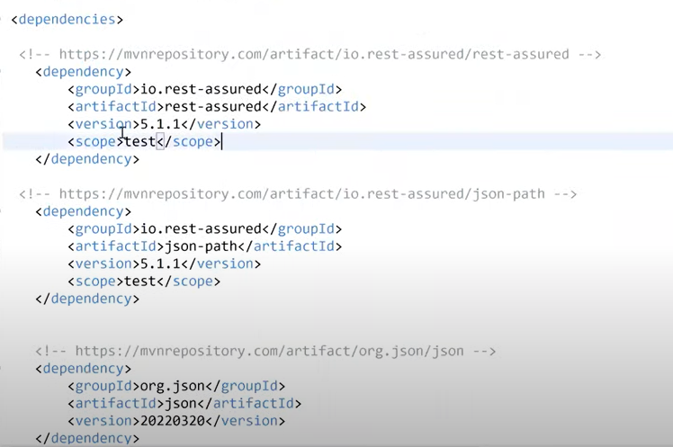

Approach 1:

Approach 2: TestNG Assertions

Approach 3: JSONObject

Checking Specific title present or not

## Parsing / Validation Response Body-XML Response